Social Media – 21 Day Shake Challenge

How to Implement the 21 Day Shake Challenge:
- YOU commit do doing it – shakes 21 days in a row, take a fun selfie, post!
- Pre-promote NOW! Announce start date, tag all of your customers, friends, etc….invite them to join you!
- START – post on Day 1
- On each post – tag all participants
- Chase the “likes” and follow up!
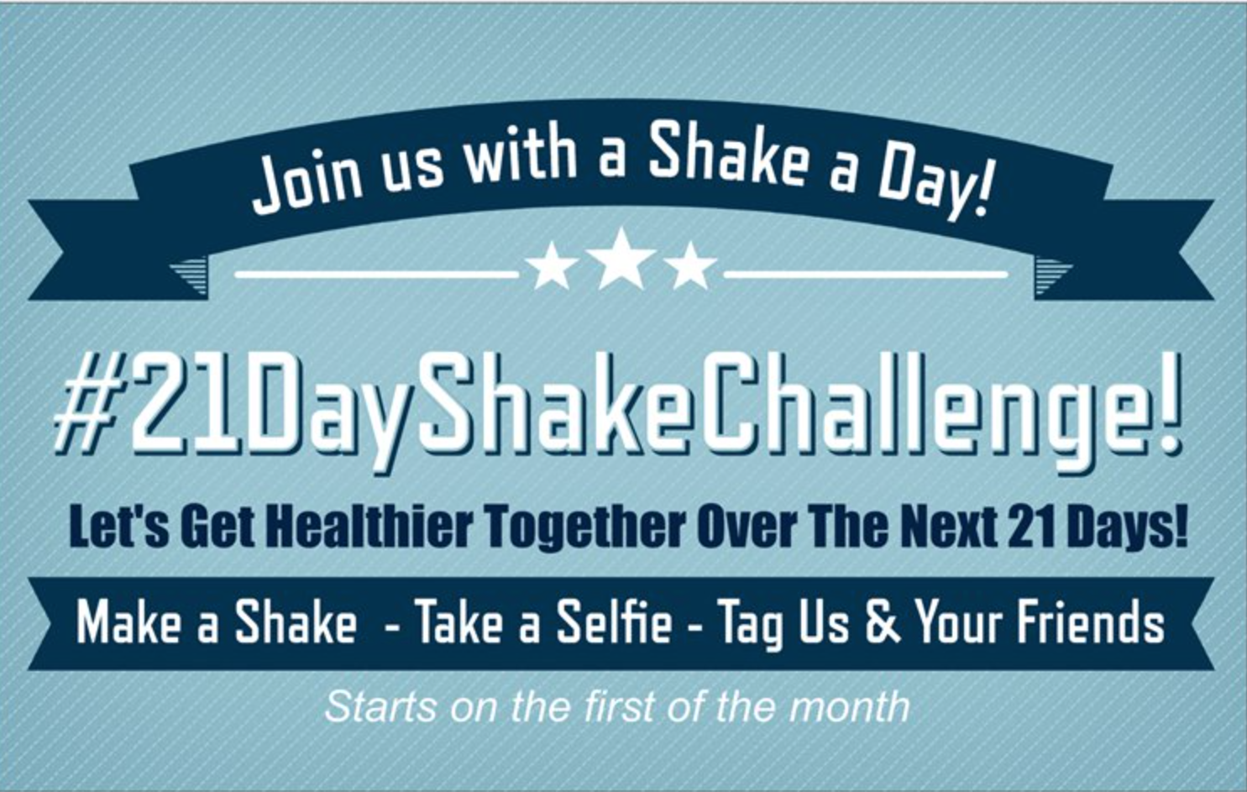

Thank you for joining us for the 21 Day Shake Challenge!

The purpose of this challenge is to help you stay focused on your health for 21 days in a row by having a healthy Herbalife Shake. We have found that with just a shake a day people have:
- Increased Energy and Health
- Maintained or even lost weight
- Increase your immune system

To take part all you need to is:
- Take a picture of you with your shake
- Post your picture on Facebook and mention your shake flavor.
- Tag your coach to get credit for your daily shake. In addition use the hashtag #21DayShakeChallenge in your posts.
- (optional) Tag your friends to encourage them to get healthy too! If your friend gets started with a 3 day trial or a can of shake with your coach you get a $5 credit on your next order. Your friends can start anytime during the 21 days.
- If you do all 21 days, you will be in the drawing for a FREE can of shake for your next 30 days.
Suggested FaceBook/Instagram Post:

Join the #21DayShakeChallenge! We are getting our community healthy and there is no better time than (insert date) to start! It all starts with just one healthy shake a day for 21 days in a row! You can:
Drop some excess weight!
Drop a pant size or two!
Tone up!
Or….just have it be a part of leading a healthier lifestyle!
There are even prizes and free support! Message me to learn more about joining in. We already have people all over the USA taking part in the #21DayShakeChallenge!

At the end of your 21 Day Shake Challenge:

On Day 21: Create and post a 15 second flipogram of your 21 days and post it on the last day of your challenge to promote the date of your next upcoming challenge. Rolling from one to the other will definitely add more people!

Social Media Golden Rule:
Ask everyone who is interested in getting started how they reached you. If it is through a FB friend who is another Herbalife Member – SEND THEM TO THAT PERSON to get started! DO NOT take other people friends as your customers!

Have a GREAT 21 DAYS!

